# VUE JS

1.What is A library ?

3.What is Composer?

4.What is framework?

## VUE JS is JavaScript framework to create a reactive web app easier.

* No refresh page

## Install global VUE JS:

* Search Install global VUE JS on google.
* Copy text in circle path in our User git bass.

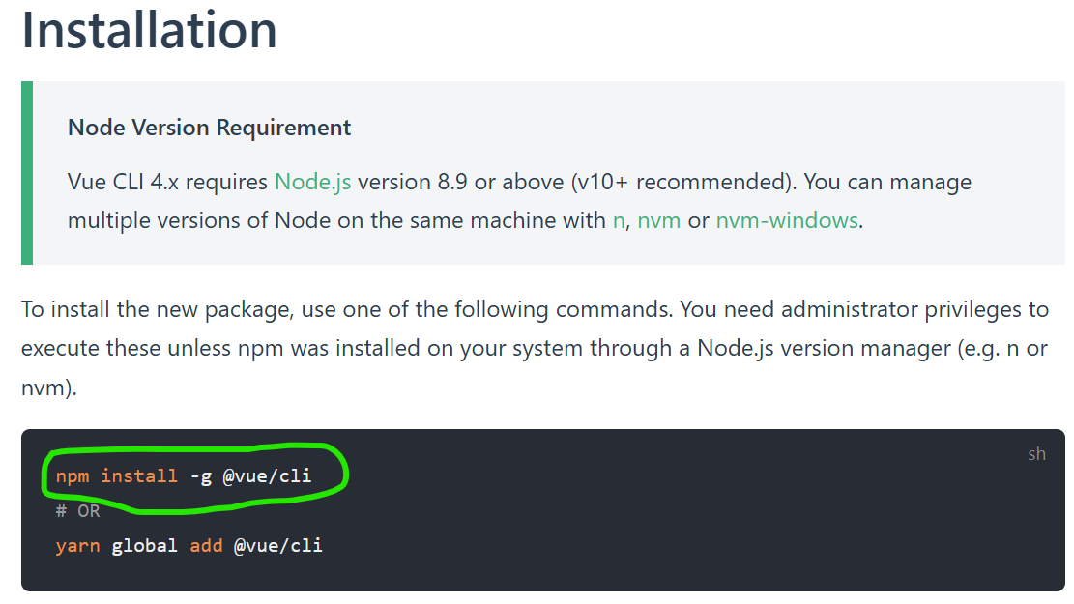

* Check VUE version:(vue –v)

Key Word To Check Overall What should we know in vue?

1.Introduction to Vue.js:Why Vue is better than Js?

2,Setting Up Environment:

-npm install -g @vue/cli (install groblally)

-vue --version (check version)

-vue create hello-world (to create porject)

3.Vue.js Basics:

-render data {{}}

-v-bin or :

-v-on or @

-v-show, v-if, v-else, v-else-if

-v-for

-method

-compute

-watch

....

4.Component-Based Architecture:

-component

-view

-include props

-include emit

5.Lifecycle Hooks:

-created

-mounted

.....

6.Forms and User Input:

-v-model

-v-validate

-Vue Devtool.

-integration with API

7.Routing

8.State Management

-state

-actions

-getters

+optional

9.Project Building (example project)

10.Options API (using data())

11.Composition API (using setup() and ref)

Ex1:

-create new project "your-name-app"

-need to display "Student Information"

-need an image below

-status:Pass or Fail (Blue or Red)

-score

-bonus: + or - (10)

1,install boostrap

-npm install bootstrap

2,config in main.js

import { createApp } from 'vue'

import App from './App.vue'

import 'bootstrap/dist/css/bootstrap.css'

import bootstrap from 'bootstrap/dist/js/bootstrap.bundle.js'

createApp(App).use(bootstrap).mount('#app')

3,uninstall

npm uninstall bootstrap